FX STRATEGY: TEMA Cross  
TEMA [14, 14, 2], EMA[100], TBR[], STO[7, 4, 4], SRLines[12]

# Overview

TEMA Cross is a strategy that follows the price action using a combination of TEMA Indicators crossing to signal entry and exit.

All indicators required to trade this strategy in Alveo can be downloaded from https://github.com/anthonypocock/Alveo

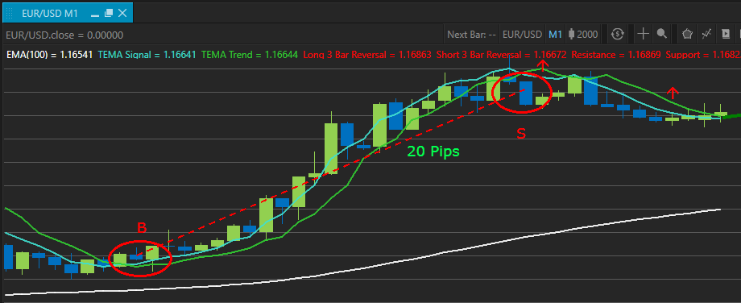

This chart shows the TEMA Cross Strategy in action.

## The Strategy

The TEMA Cross Strategy utilizes the indicators TEMA[14, 0] as the signal, and a TEMA[14, 2] as the baseline. When the signal TEMA crosses above the base TEMA, a long trade is triggered.

Conversely, when the signal TEMA crosses below base TEMA, a short trade is triggered.

In order to filter out lower probability trades, an EMA[100] can be used to indicate the preferred trade direction. Whilst the moving average provides a good rule of thumb to indicate the trend direction, trading against the trend should still be considered where price action warrants it, although tighter stops are then recommended.

The Stochastic and SRLines indicators can be used to add confidence to the entry and exit decisions. STO provides confirmation as the STO signal crosses STO base line and SRLines shows the price bouncing off support / resistance and back to the TEMA Cross entry point.

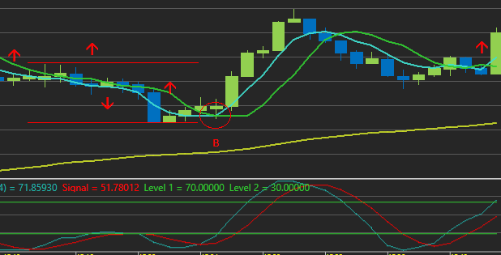

Additional tools like the Three Bar Reversal indicator may be used to increase understanding of the nature of the price action, and add confidence to entry and exit decisions

### TEMA CROSS Strategy Rules

#### 1: Look for TEMA Cross

In order to be sure that the TEMA cross is confirmed, it is prudent to wait until the candle containing the cross is closed before entering the trade. Waiting for that next candle also limits the likelihood of being whipsawed out of the trade.

#### 2: Check direction of trend

If a high probability win is desired, trading only with the trend is advised. Check the direction of the EMA[100] and choose a trade in line with that.

##### 3: Look for confirmation

When price bounces off support or resistance and a TEMA cross entry signal occurs soon after, there is a high probability that the trade will continue to move into positive pips. Checking that Stochastic is crossing and passing out of the over-bought / over-sold region should also add confidence to the trade.

##### 4: Stop Loss

The type of stop loss used can be selected at your discretion, just make sure you use a stop loss! A good starting point is to place your initial stop loss just beneath the most recent swing low for a long / buy, or above the recent swing high for a short / sell. This point usually is the same as indicated by the SRLines indicator, depending on the number of SRLines bars being displayed. Recent price action should always be the driver in your final stop loss placement, as a more volatile price environment may require a larger buffer between the entry and stop loss. Moving the stop loss up to just above break-even is advised once the trade direction is established and a sufficient pip buffer is reached.

##### 5: Take Profit

Your take profit point should change based on the number of pips already banked in the trading session. At the beginning of the session, a more conservative approach based on price action is acceptable in order guarantee pips banked. As the session progresses and a positive balance is achieved, you may choose to let the trade run until the reversal TEMA cross exit signal is seen. The let it run approach will generate more pips, but also runs the risk of an unexpected reversal and potential slippage as a stop loss is triggered.

A good approach can be to open ~3 trades in the position on the TEMA entry signal. The first two can be closed at conservative levels to guarantee pips banked, with the third running free until the exit cross signal.

